Step to use mutation testing

Number：2017329621139 Name：徐政辉 Class：17计科全英文

1. first download the eclipse from the web site <https://www.eclipse.org/downloads/>
2. download MuClipse from the official website: <http://muclipse.sourceforge.net/index.php>



<https://sourceforge.net/projects/muclipse/>

1. put the .jar file to the plugins directory
2. open eclipse, create a project as show in the zip package, with the file like this:

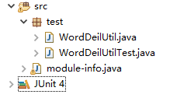

For each file, I write the content as below:

**WordDeilUtil:**

package test;

import java.util.regex.Matcher;

import java.util.regex.Pattern;

public class WordDeilUtil {

public static String wordFormat4DB(String name) {

if (name == null)

return null;

Pattern p = Pattern.compile("[A-Z]");

Matcher m = p.matcher(name);

StringBuffer sb = new StringBuffer();

while (m.find()) {

if (m.start() == 0)

m.appendReplacement(sb, m.group());

else

m.appendReplacement(sb, "_" + m.group());

}

return m.appendTail(sb).toString().toLowerCase();

}

}

**WordDeilUtilTest:**

**package** test;

**import** **static** org.junit.Assert.*assertEquals*;

**import** **static** org.junit.Assert.*assertNull*;

**import** org.junit.After;

**import** org.junit.Before;

**import** org.junit.Test;

**import** test.WordDeilUtil;

**public** **class** WordDeilUtilTest {

@Before

**public** **void** setUp() **throws** Exception {

}

@After

**public** **void** tearDown() **throws** Exception {

}

@Test

**public** **void** wordFormat4DBNormal() {

String target = "employeeInfo";

String result = WordDeilUtil.*wordFormat4DB*(target);

*assertEquals*(result, "employee_info");

}

@Test

**public** **void** wordFormat4DBNull() {

String target = **null**;

String result = WordDeilUtil.*wordFormat4DB*(target);

*assertNull*(result);

}

@Test

**public** **void** wordFormat4DBEmpty() {

String target = "";

String result = WordDeilUtil.*wordFormat4DB*(target);

*assertEquals*(result, "");

}

@Test

**public** **void** wordFormat4DBBegin() {

String target = "EmployeeInfo";

String result = WordDeilUtil.*wordFormat4DB*(target);

*assertEquals*(result, "employee_info");

}

@Test

**public** **void** wordFormat4DBEnd() {

String target = "employeeInfoA";

String result = WordDeilUtil.*wordFormat4DB*(target);

*assertEquals*(result, "employee_info_a");

}

@Test

**public** **void** wordFormat4DBTogether() {

String target = "employeeAInfo";

String result = WordDeilUtil.*wordFormat4DB*(target);

*assertEquals*(result, "employee_a_info");

}

}

1. follow the official instruction to configure the environment
2. run 
3. result:

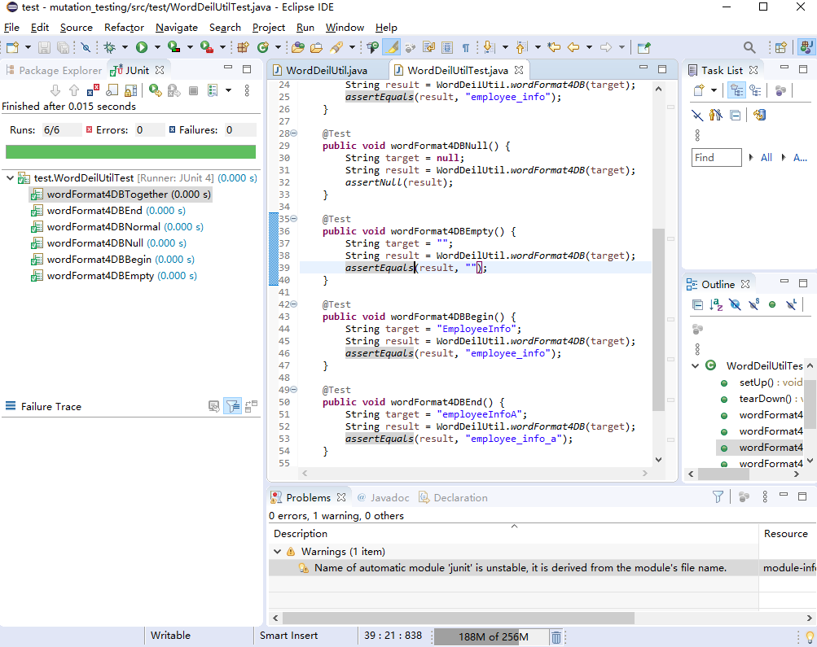

All the amutation testing pass.

